**Program No.06**

**Program title** gas sensor

**Aim**

To on led when gas is present

**Hardware Required**

Arduino board

gas sensor

led

**Circuit**

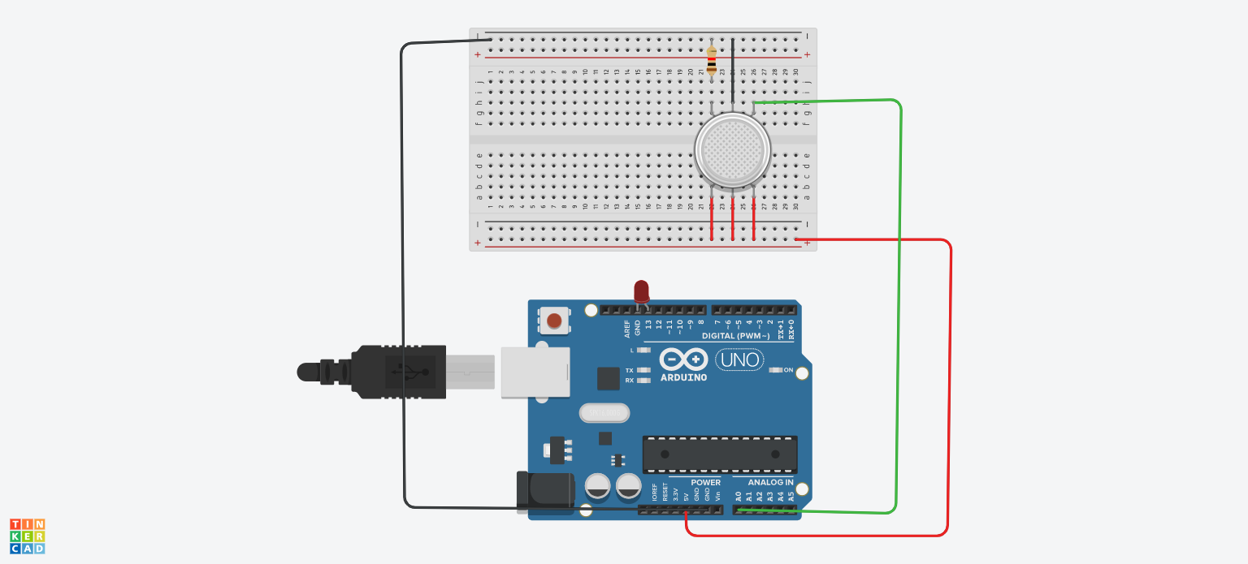

**Code**

void setup()

{

Serial.begin(9600);

pinMode(13, OUTPUT);

}

void loop()

{

float sensorvalue = analogRead(A0);

Serial.print("\nsensor value=");

Serial.print(sensorvalue);

if(sensorvalue>111)

{

digitalWrite(13,HIGH);

}

else

digitalWrite(13,LOW);

}